POWER BI SALES PERFORMANCE ANALYSIS CAPSTONE PROJECT
2026

METHODOLOGY: CRISP-DM
BY: Bridgit Etyang

EXECUTIVE SUMMARY
This project analyzed sales data using Power BI to generate insights into sales performance, profitability, product trends, and regional performance using the CRISP-DM methodology.
Data cleaning and transformation were performed in Power Query Editor to handle missing values, remove errors and duplicates, and prepare the dataset for analysis. Interactive dashboards were developed to visualize key metrics such as Total Sales, Total Profit, Profit Margin, and Year-over-Year growth.
The analysis showed that the West region generated the highest sales, while the South region generated the highest profit. Office Supplies was the top-performing category, while Technology showed strong profitability and growth potential. The insights obtained can support strategic decision-making and improve overall business performance.

1. BUSINESS UNDERSTANDING
Organizations rely on sales analytics to monitor business performance, identify profitable markets, evaluate product performance, and support strategic decision-making. In this project, Power BI was used to analyze sales transaction data in order to generate insights related to sales trends, profitability, customer demand, and business growth.
The analysis aimed to support management decision-making by identifying high-performing regions, profitable product categories, and growth opportunities. Interactive dashboards were created to help stakeholders monitor key business metrics and evaluate overall organizational performance.
Problem Statement
The company needs to understand which regions, product categories, and subcategories generate the highest sales, profit, and year-over-year growth in order to improve decision-making, optimize profitability, allocate budgets effectively, and identify future growth opportunities.
Key Business Questions
- Which region generates the highest sales and profit?
- Which product categories and subcategories perform best?
- What are the total sales and profits across regions and categories?
- How does the business perform year-over-year?
- Which areas require improvement in profitability and operational efficiency?

2. DATA UNDERSTANDING
The dataset used in this analysis contained sales transaction information across different regions, states, product categories, and subcategories. The dataset provided detailed information about orders, sales values, profits, quantities, and shipping dates.
The dataset contained several important variables including: Order date, ship date, region, state, category, subcategory, sales, profit, quantity, order id.
These variables enabled analysis of: sales performance, regional trends, profitability, product performance, year-over-year growth and customer demand patterns.
Initial exploration of the dataset involved: Reviewing the structure of the dataset, identifying missing values, detecting duplicate records, checking for inconsistencies and errors in the data.
The data was imported into Power BI and transformed using Power Query Editor.

3. DATA PREPARATION
Data preparation was conducted in Power Query Editor to ensure the dataset was clean, accurate, and suitable for analysis.
Removal of Errors
Errors were identified in: Date columns and quantity columns. The errors were removed using the remove errors functionality in Power Query Editor. This ensured consistency and reliability within the dataset.
Duplicate Check
The dataset was checked for duplicate records using the Order ID column as the unique identifier. Duplicates were removed using: Remove Rows dropdown then remove duplicates option. This ensured that each transaction appeared only once in the dataset.
Missing Values
Missing values were identified in: Order Date, region and sales columns where different techniques were used depending on the type of variable.
To fill missing Order Date values, the difference between Ship Date and Order Date was calculated to determine the average shipping duration. The average shipping duration was approximately 5 days. The missing Order Dates were estimated by subtracting five days from the Ship Date values. This provided a logical estimate for the missing dates.
The missing Region values were replaced using the mode (most frequent value), which was “South”. This method was suitable because Region is a categorical variable.
The Sales column also contained missing values and since no logical formula existed to calculate the missing sales values, the missing entries were replaced using the fill down option.
Data Formatting
After cleaning the data: Order Date and Ship Date columns were converted into Short Date format. This improved consistency and supported time-based analysis within Power BI.

4. DATA MODELING
To improve analysis and reporting, additional tables were created to form a star schema model within Power BI.
Star Schema Model
The model consisted of: Fact Table (Sales Table) and Dimension Tables (Date table, category table, subcategory table and region table).
This structure improved: Relationship management, query performance, scalability and dashboard efficiency.
Creation of Date Table
A Date Table was created using DAX to support time intelligence calculations. The table included: Date, year, month, month number, quarter and day columns. The Date Table enabled: Year-over-year analysis, time-based filtering and trend analysis.
Creation of Category Table
A Category ID column was first added to the Sales table to act as a primary key.
The Category table was then created using the Group By function and contained: Category and Category ID columns.
This enabled relationship creation between the Sales table and the Category table.
Creation of Subcategory Table
A Subcategory ID column was added to the Sales table.
A Subcategory dimension table was then created using the Group By function.
The table contained: Subcategory and Subcategory ID columns.
Creation of Region Table
A State ID column was created in the Sales table to act as a unique identifier.
The Region table contained: Region, state and state id columns. This enabled regional analysis and relationship mapping.
Relationship Creation
Relationships were created between:
- Sales Table and Date Table
- Sales Table and Category Table
- Sales Table and Subcategory Table
- Sales Table and Region Table
This successfully formed a star schema model.
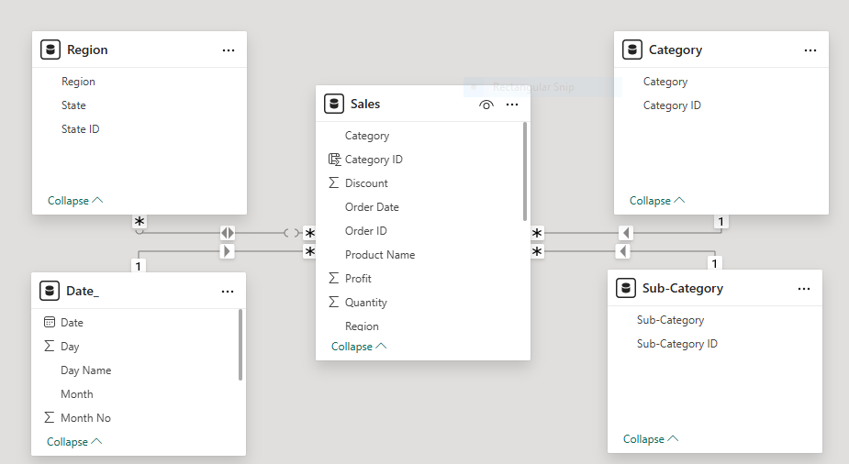
Measure Creation
Several DAX measures were created to support business analysis, including: Total Sales, total profit, total sales year-to-date (YTD), previous year sales and Year-over-Year (YOY) Sales.
These measures enabled dynamic and interactive reporting within Power BI.

5. EVALUATION
The analysis generated several important insights related to sales performance, profitability, regional performance, product trends, and business growth.
Key Findings
1. West Region Generated the Highest Sales
The West region recorded the highest sales contribution among all regions, indicating strong customer demand and market performance. The strong sales performance suggests that the company has an established customer base and effective distribution channels within the West region.
2. South Region Generated the Highest Profit
Although the West region generated the highest sales, the South region produced the highest overall profit. This indicates better profit margins, lower operational costs and more effective pricing strategies compared to other regions.
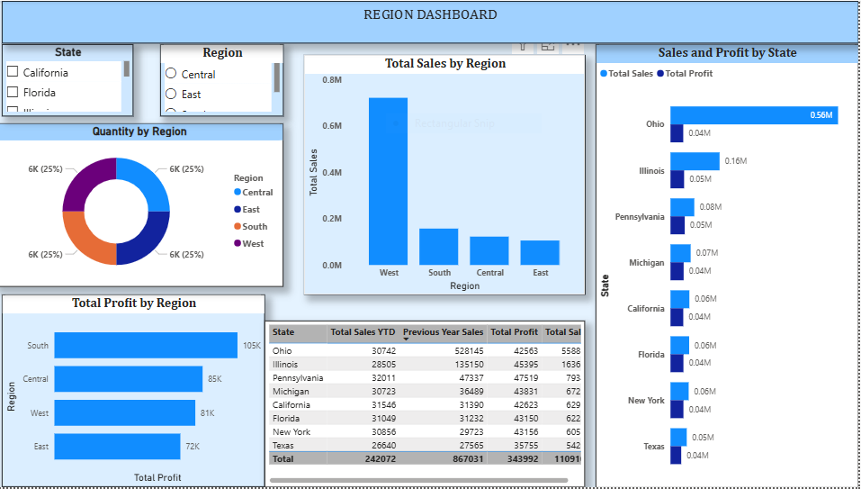
3. Office Supplies Generated the Highest Sales
The Sales Dashboard showed that the Office Supplies category generated the highest total sales of approximately 0.67M, outperforming Furniture and Technology. This indicates strong customer demand for office-related products and suggests that Office Supplies represent a core revenue-generating category.
4. Paper Was the Best Performing Subcategory
The dashboards showed that Paper generated the highest sales among all subcategories at approximately 0.55M. Other strong-performing subcategories included: Tables, pens, laptops, bookcases. Paper products appear to have: Strong and consistent customer demand, high sales volume, stable profitability making them a key driver of business revenue.
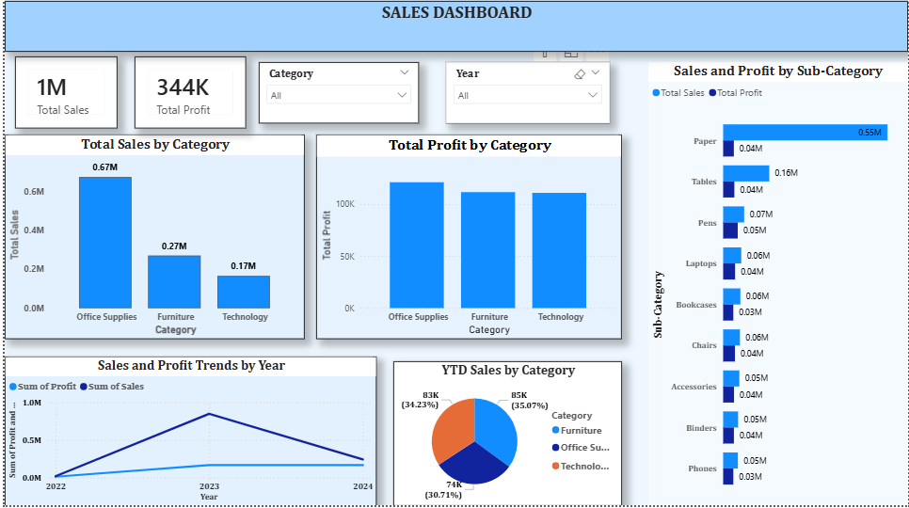
5. Strong Year-over-Year Growth
The Product Dashboard revealed strong year-over-year sales growth across several subcategories.
Highest YOY Growth Subcategories
Chairs – 124.68%, laptops – 122.54%, phones – 93.60%, accessories – 86.35%, bookcases – 72.83%. The extremely high YOY growth in Chairs and Laptops indicates rapidly increasing demand and strong market expansion opportunities.
6. Sales and Profit Peaked in 2023
The Sales Dashboard trend analysis showed that both sales and profit reached their highest levels in 2023 before slightly declining in 2024. The strong performance in 2023 reflects a period of business growth and improved sales performance. The slight decline in 2024 may indicate: Market saturation, increased competition and changing customer demand. This suggests the need for renewed strategic marketing and operational improvements.
7. Balanced Product Distribution Across Categories
The Product Dashboard donut chart showed that product quantity distribution across categories was relatively balanced: Office Supplies ≈ 35%, Furniture ≈ 32%, Technology ≈ 32%. This balanced distribution reduces overdependence on a single category and supports diversified business performance.
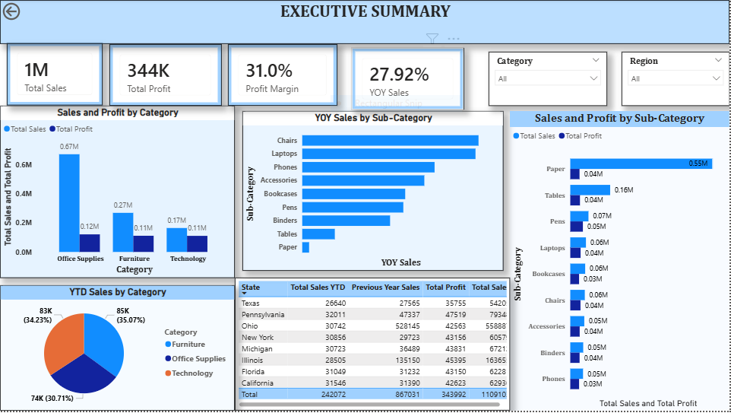

6. RECOMMENDATIONS
Based on the analysis, several recommendations can be made to improve business performance and profitability.
- Improve Profitability in the West Region
Although the West region generates the highest sales, its profit margins are lower than the South region. The company should: Review operational costs, optimize pricing strategies, reduce excessive discounting.
- Expand in High-Performing Regions
Regions such as the West and South showed strong performance. The company should: Strengthen distribution networks, increase marketing activities and Expand customer outreach in these regions.
- Invest More in High-Growth Subcategories
Subcategories such as: Chairs, laptops, phones and accessories showed exceptionally high year-over-year growth. The company should: Increase marketing efforts, improve inventory availability and prioritize these products in future sales strategies.
- Improve Performance of Low-Selling Subcategories
Products such as Binders and Phones recorded comparatively lower sales values. The company should review: Pricing strategies, Product visibility, Promotional campaigns in order to improve performance.
- Strengthen Long-Term Growth Strategies
Since sales and profits peaked in 2023 before slightly declining in 2024, the company should: Improve customer retention strategies, introduce new promotional campaigns, expand into new markets and strengthen product innovation
- Monitor Business Performance Regularly
The dashboards should continue to be used for: Monitoring sales trends, tracking profitability, evaluating business growth and supporting strategic decision-making.

7. DEPLOYMENT (DASHBOARD)
Interactive Power BI dashboards were created to visually present the insights. The dashboards included: Sales Overview Dashboard, product dashboard, region dashboard, executive summary dashboard.
The dashboards displayed: Total sales metrics, profit performance, regional analysis, product category performance, year-over-year growth trends and subcategory analysis.
The dashboards enable stakeholders to: Monitor business performance, identify trends, compare regional and product performance and make informed business decisions.
The use of slicers and interactive visuals improved user experience and allowed dynamic filtering across categories and years.

